LAB 4: Diode Clampers

**Date: Reg.#:**

## OBJECTIVES:

## To study diode as negative and negative biased clamper.

## To study diode as positive and positive biased clamper.

## EQUIPMENT AND COMPONENTS:

* Basic Circuits Training Board
* 1N4007 Rectifier Diode
* Jumper Wires
* Palm Scope / DMM
* Resistors
* Electrolyte Capacitors
* Voltage Transformer

---------------------------------------------------------------------------------------------------------------------

## Clamper:

A clamper is an electronic circuit that changes the DC level of a signal to the desired level without changing the shape of the applied signal. In other words, the clamper circuit moves the whole signal up or down to set either the positive peak or negative peak of the signal at the desired level.

The dc component is simply added to the input signal or subtracted from the input signal. A positive clamper circuit adds the positive dc component to the input signal to push it to the positive side. Similarly, a negative clamper circuit adds the negative dc component to the input signal to push it to the negative side.

Clamping can be performed by using one of the following types depending upon the applications.

* Negative Clamper
* Biased Negative Clamper
* Positive Clamper
* Biased Positive Clamper

## Negative clamper:

A negative clamper circuit is one that consists of a diode, a resistor and a capacitor and that shifts the output signal to the negative portion of the input signal. The figure below explains the construction of a negative clamper circuit.

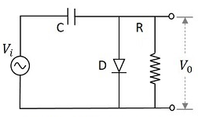

Fig: Negative Clamper Circuit

During the positive half cycle, the capacitor gets charged to the peak value $V_{m}$ of the applied input signal. The diode is forward biased and conducts. During the negative half cycle, the diode gets reverse biased and behaves like an open circuited. Hence the signal is negatively clamped as shown. The output signal changes according to the changes in the input, but shifts the level according to the charge on the capacitor, as it adds the input voltage.

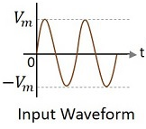 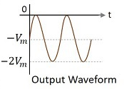

Fig: Negative Clamper Output

## Biased negative clamper (with positive reference voltage):

A negative clamper circuit if biased with some positive reference voltage, that voltage will be added to the output to raise the clamped level. Using this, the circuit of the negative clamper with positive reference voltage is constructed as below.

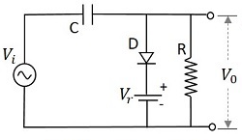

Fig: Biased Negative Clamper Circuit Circuit

Though the output voltage is negatively clamped, a portion of the output waveform is raised to the positive level, as the applied reference voltage is positive. During the positive half-cycle, the diode conducts, but the output equals the positive reference voltage applied. During the negative half cycle, the diode acts as open circuited and the voltage across the capacitor forms the output.

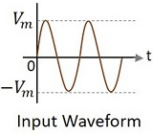 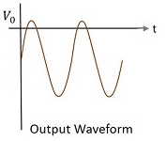

Fig: Biased Negative Clamper Output

## Positive Clamper:

A positive clamper circuit is one that consists of a diode, a resistor and a capacitor and that shifts the output signal to the positive portion of the input signal. The figure below explains the construction of a positive clamper circuit.

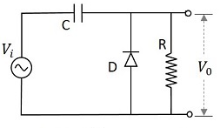

Fig: Positive Clamper Circuit

Initially when the input signal is applied, then during the positive half cycle, the capacitor will not be able to charge itself as the diode is reverse biased. During the negative half cycle, at the peak value, the capacitor gets charged with negative charges on right-hand plate and positive charges on the left-hand plate. The capacitor is now charged to its peak value. The diode is forward biased and conducts.

During the next positive half cycle, the capacitor has already been charged to the peak value of the input signal while the diode gets reverse biased (behaves like an open circuit) again.

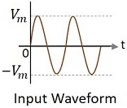 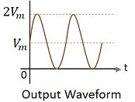

Fig: Positive Clamper Output

## Biased Positive Clamper (with positive reference voltage):

A positive clamper circuit if biased with some positive reference voltage, that voltage will be added to the output to raise the clamped level. Using this, the circuit of the positive clamper with a positive reference voltage is constructed as below.

During the positive half cycle, the reference voltage is applied through the diode at the output and as the input voltage increases, the cathode voltage of the diode increase with respect to the anode voltage and hence it stops conducting. During the negative half cycle, the diode gets forward biased and starts conducting. The voltage across the capacitor and the reference voltage together maintain the output voltage level.

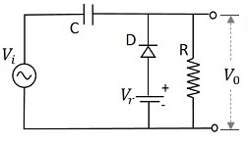

Fig: Biased Positive Clamper Circuit

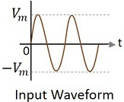 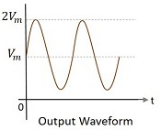

Fig: Biased Positive Clamper Output

## Observations:

**Vpp = __________**

**R = __________**

**C = __________**

**f = __________**

## Tasks:

* Perform all the calculations of the output voltage and capacitor voltage on separate A4 pages.
* Attach all the pictures of the corresponding output waveforms.
* Indicate the voltage levels on the output waveforms.
* Perform all the calculations of the biased positive clamper (with a negative dc battery) that was assigned during the lab.

**Positive Clamper Output:**

**Negative Clamper Output:**

**Biased Positive Clamper (with positive reference voltage):**

**Biased Negative Clamper (with positive reference voltage):**

# REVIEW QUESTIONS:

Q: How does the output of a clamper differ from that of a shunt clipper?

Q: Why the value of resistor and capacitor was chosen so large in the practical? Give logical explanation.

Q: Write any five applications of clampers?